Isaiah 29—KJV JST 2 Nephi 26-27

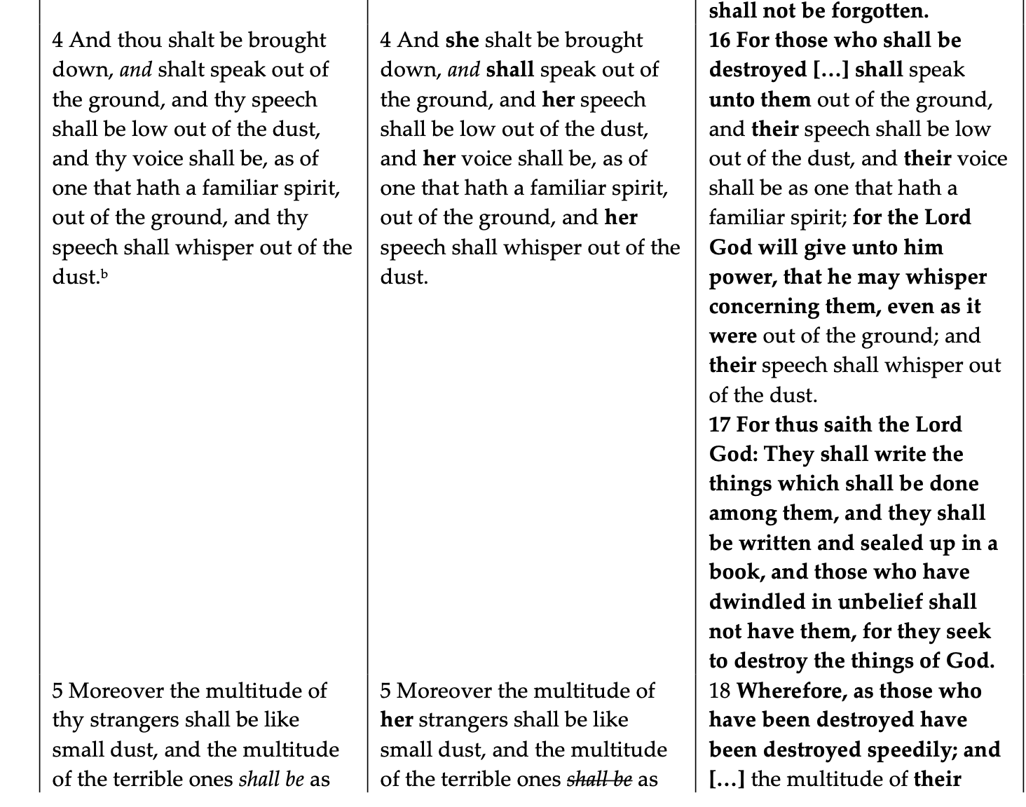
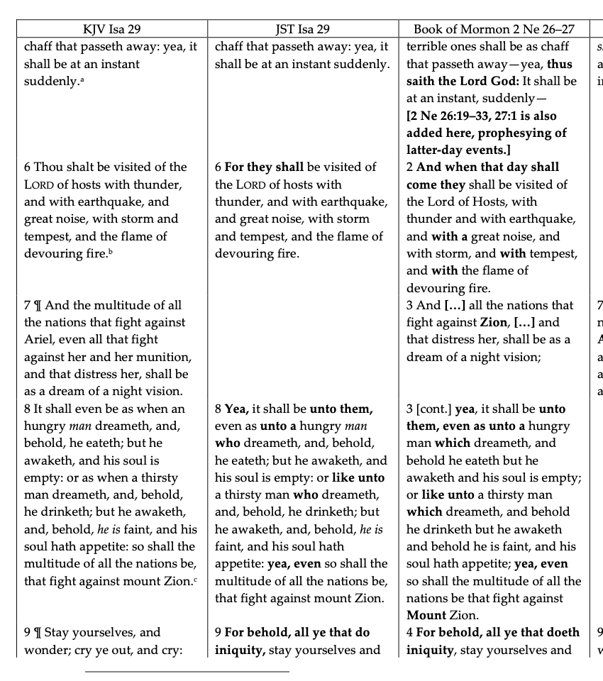

From: CHRISTIANITY.COM
This chapter contains a prophecy concerning the destruction of the temple and city of Jerusalem by the Romans; the character and condition of the people of the Jews, previous to it; the calling of the Gentiles, by the preaching of the Gospel; the ruin of antichrist, and the conversion of the Jews, in the latter day. The siege and destruction of Jerusalem are described in Isaiah 29:1 the disappointment of their enemies, notwithstanding their taking and destroying it, Isaiah 29:7 the stupidity, judicial blindness, and hardness of the Jews, which brought on their ruin, are predicted, Isaiah 29:9 the ignorance of their learned, as well as of their unlearned men, with respect to the Scripture, and the prophecies of it, Isaiah 29:11 their hypocrisy and formality in worship, Isaiah 29:13 a blast upon all their wisdom and prudence, who thought to be wiser than the Lord, and too many for him, whose folly and atheism are exposed, Isaiah 29:14, and a great change both in Judea and the Gentile world, by the removal of the Gospel from the one to the other, Isaiah 29:17 the effects of which are, deaf sinners hear the word, dark minds are enlightened, and joy increased among the meek and poor, Isaiah 29:18 the fall of the Jews, or else of antichrist, is foretold, Isaiah 29:20 and the chapter is closed with a promise and prophecy of the conversion of the seed of Abraham and Jacob, Isaiah 29:22.
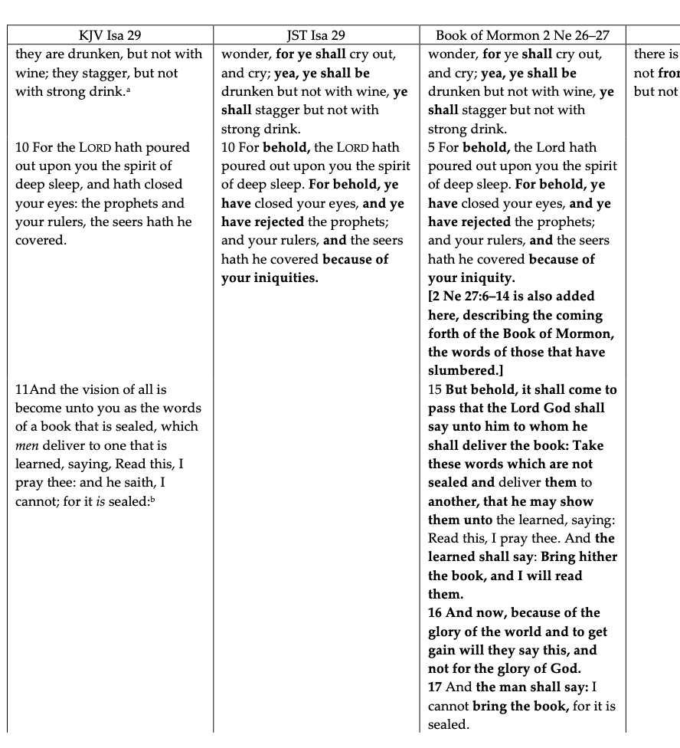
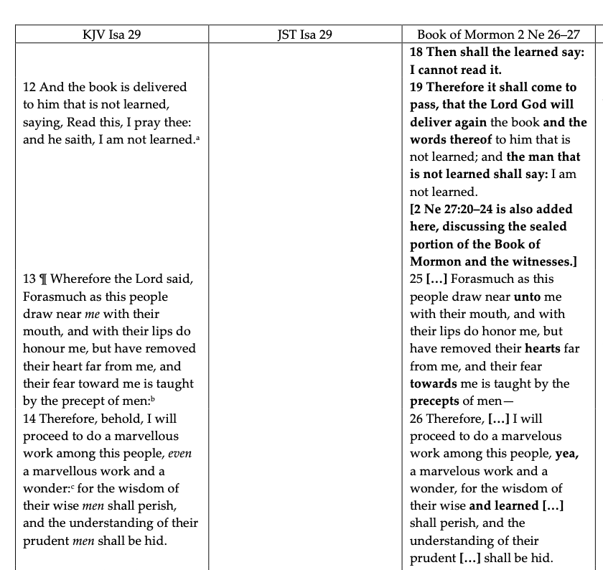

“Marvelous Work” Usage in Scripture

OT: “His marvelous works”
Book of Mormon:
Marvelous work among Gentiles
- 1 Ne 14:7
- 1 Ne 22:8
- 2 Ne 25:17
- 2 Ne 27:6-35
- 2 Ne 29:1
Doctrine & Covenants
[A Great &] Marvelous Work
- D&C 4:1
- D&C 6:1
- D&C 8:8
- D&C 10,
- D&C 11,
- D&C 12,
- D&C 14,
- D&C 18,

- Ps 9:11;
- Ps 26:7;
- Ps 40:5
- Ps 71:17;
- Ps 75:1;
- Ps 78:4, 11, 32;
- Ps 96:3;
- Ps 105:2, 5;
- 1 Chr 15:12; 16:19, 24;
- Isa 29:14
- Jer 21:2

Historical Timeline of One Fulfillment of Isaiah 29:11-14
1827
January 18 Marriage of Joseph Smith and Emma Hale; they move in with the Smiths in the new frame home.
September 22 Joseph and Emma ride together to the Hill Cumorah; Joseph obtains the golden plates and interpreters from angel Moroni.
December Joseph and Emma move to Harmony, Pennsylvania.

1828
January Joseph translates the “Egyptian Caracters [sic]” from the plates.

February Martin Harris takes “Egyptian caracters” and shows them to Classics professors in New York: Luther Bradish, Charles Anthon, and Dr. Samuel Mitchell.
March Martin and his wife Lucy journeys to Harmony, Pennsylvania.
April 12-June 14 Martin acts as scribe for Joseph Smith as he translates the Book of Lehi.

Isaiah 29:11-14 Fulfillment by Martin Harris and Professor Charles Anthon

In addition to donating his money, Martin Harris also donated his time to the young Prophet Joseph Smith. In February 1828, Martin journeyed from Palmyra to Harmony to ask Joseph if he could take a transcription of the Egyptian characters and Joseph’s translation to New York City. Joseph agreed, and Martin left to visit two experts and a wealthy friend: Charles Anthon at Columbia College, Professor Samuel Mitchell, a linguist, and Luther Bradish, a wealthy politician. He stopped off to see his wealthy friend first in Albany, and then continued traveling to NYC. At Columbia College, Martin showed the characters to Charles Anthon, one of the five most preeminent professors of classics in the nation. (In 1828, no one in the United States could read Egyptian. The Rosetta Stone had been discovered and was being studied in Europe, but unknown in the USA.) At some point, Anthon encouraged Martin to visit his emeritus colleague, the esteemed linguist, Samuel Mitchell.
The action of Martin Harris showing the reformed Egyptian characters to professors from Columbia College resonates with the prophecy found in Isaiah 29:11-14 and suggests that the Lord has intimate knowledge of Martin’s life’s details. The connection also speaks of God respect for ancient covenants.
Charles Anthon certified in writing that the characters were “Egyptian, Chaldaic, Assyriac, and Arabic” (JS-H 1:63-65). Yet, upon learning that an angel had given Joseph Smith the gold plates from which the characters were transcribed, Anthon tore up the certificate. Nevertheless, the initial words and actions of Anthon was enough to convince Martin Harris of the veracity of the plates and to act as scribe for the Book of Lehi, and to put 150 acres of his farm as collateral for the publication of the Book of Mormon.

Martin Harris—A Supportive Scribe and Unsatisfied Witness

After returning from New York City, Martin felt assured enough to proceed with helping Joseph on the translation. In March, Martin and his wife Dolly visited Joseph and Emma in Harmony. Dolly Harris tried in vain to see the plates. She tore through the house in search of them, but she did not find them, and became angry. Mother Smith remembered: “Mrs. H went from place telling her grievances to everyone she met but particularly bewailing that the deception which Joes Smith was practicing” (Lucy Mack Smith, History, 1844-1845, p. [10], bk. 6; josephsmithpapers.org). Mrs. Harris finally returned home from, Pennsylvania to New York, very disappointed. In spite of the marital strife on the matter, Martin chose to return to Harmony to assist Joseph as a scribe for the Book of Lehi (the first 116 pages translated from Moroni’s edited version—that fit in chronologically before Mosiah).

